**Loop Diagram**

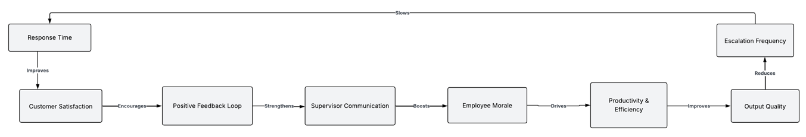

This diagram illustrates a performance-enhancing feedback loop linking Customer Satisfaction, Employee Morale, and Productivity. Improved Response Time enhances Customer Satisfaction, which encourages a Positive Feedback Loop (Romano & Conti, 2024). This strengthens Supervisor Communication, boosting Employee Morale, which drives Productivity & Efficiency. Higher Output Quality then reduces Escalation Frequency, which in turn slows Response Time, completing the cycle. In real-world scenarios, this model helps businesses identify leverage points—like communication and morale—that significantly influence service quality, operational efficiency, and customer retention (Lakshmi & Ajay, 2024). It's especially useful in service industries, guiding HR, operations, and customer support strategies to achieve sustainable organizational performance.

**References**

Lakshmi, H., & Ajay, S. (2024). Learning loops and the process of continuous. *Unleashing Absorptive Capacity and Unlearning for Organizational Excellence*, 113. <https://books.google.com/books?hl=en&lr=lang_en&id=9MksEQAAQBAJ&oi=fnd&pg=PA113&dq=Feedback+Loop+businesses+identify+leverage+points%E2%80%94like+communication+and+morale%E2%80%94that+significantly+influence+service+quality,+operational+efficiency,+and+customer+retention&ots=9Ml5GZft5B&sig=Y21QIHXQqOdBabD8RlGqQ5EmuWI>

Romano, G., & Conti, A. (2024). The role of Customer Feedback Loops in driving Continuous Innovation and Quality Improvement. *National Journal of Quality, Innovation, and Business Excellence*, *1*(2), 30-39. <https://theeducationjournals.com/index.php/NJQIBE/article/view/142>